A Project Report on

**Indian Sign Language Recognition**

Submitted for Artificial Intelligence (UCS411)

by

**Sezalpreet Kaur 102103531**

**Khushi Agarwal 102103549**

**Samarjeet Singh 102103561**

**Aditya Singh 102103558**

**Submitted to**

**Dr Gourav Jain**



**DEPARTMENT OF COMPUTER SCIENCE AND ENGINEERING**

**THAPAR INSTITUTE OF ENGINEERING AND TECHNOLOGY, (A DEEMED TO BE UNIVERSITY), PATIALA, PUNJAB**

**INDIA**

**Jan-May 2023**

**Introduction:**

Sign language recognition systems have become increasingly important in recent years to facilitate communication between hearing-impaired individuals and the wider community. Millions of people worldwide rely on sign language as their primary means of communication, and the development of systems that can accurately recognize and interpret sign language can help to break down barriers to communication.

One of the most widely used sign languages is Indian Sign Language (ISL), which is used by millions of people in India. In this project, we aim to develop a system for recognizing ISL hand signs using Python, Mediapipe, and a Random Forest Classifier. The system will allow users to input hand signs through a camera feed and accurately identify the corresponding sign in real-time.

The core of our system will be a Random Forest Classifier, a machine learning algorithm that can effectively classify input data into discrete categories based on their features. The algorithm will be trained on a large dataset of ISL hand signs to learn the key features of each sign and how they relate to the corresponding word or phrase. Once the model has been trained, it can be used to classify new hand gestures input through the camera feed, allowing users to quickly and accurately identify the corresponding sign.

The potential impact of this system is significant. By enabling real-time recognition of ISL hand signs, the system could greatly enhance communication between hearing-impaired individuals and the wider community. For example, in educational settings, the system could be used to facilitate communication between teachers and hearing-impaired students, enabling more effective learning and participation. In healthcare settings, the system could be used to facilitate communication between medical professionals and hearing-impaired patients, improving access to healthcare and reducing the potential for miscommunication or misunderstandings. In public service settings, the system could be used to facilitate communication between hearing-impaired individuals and public officials, enabling more effective participation in democratic processes.

In conclusion, the development of a sign language recognition system for Indian Sign Language has the potential to greatly enhance communication between hearing-impaired individuals and the wider community. By enabling real-time recognition of ISL hand signs, the system can help to break down barriers to communication and create new employment opportunities for people with hearing impairments. It can also promote awareness and understanding of sign language and the importance of accessible communication, helping to create a more inclusive society.

**Literature Survey:**

Sign language detection has been an active area of research for many years, with numerous studies investigating various aspects of the problem. In particular, researchers have been interested in developing automatic systems that can accurately recognize sign language gestures and translate them into spoken or written language. Here is a brief literature survey on sign language detection on ISL (Indian Sign Language):

1. "Sign Language Recognition System for Indian Sign Language using Kinect Sensor" (2016) by P. N. Nayak and K. Prasad: This study proposed a sign language recognition system using the Kinect sensor to capture hand gestures in ISL. The system achieved an accuracy of 85% in recognizing ISL signs.

* Limited number of participants in the study, which may not represent the diversity of hand gestures in ISL.
* The study did not compare the proposed system with other existing methods, making it difficult to evaluate its performance relative to other approaches.

2. "Real-time recognition of Indian Sign Language using Leap Motion Controller" (2019) by S. R. Balamurugan and S. Balaji: This study proposed a real-time sign language recognition system using the Leap Motion Controller to capture hand gestures in ISL. The system achieved an accuracy of 91% in recognizing ISL signs.

* Limited evaluation of the proposed system on a small dataset of only 100 signs, which may not be sufficient to evaluate the system's accuracy on a larger and more diverse set of hand gestures.
* The study did not compare the proposed system with other existing methods, making it difficult to evaluate its performance relative to other approaches.

3. "Indian Sign Language Recognition using Deep Learning Techniques" (2020) by M. K. Kumari and S. N. Omkar: This study proposed a sign language recognition system using deep learning techniques to recognize ISL signs. The system achieved an accuracy of 94% in recognizing ISL signs.

* Limited evaluation of the proposed system on a small dataset of only 150 signs, which may not be sufficient to evaluate the system's accuracy on a larger and more diverse set of hand gestures.
* The study did not compare the proposed system with other existing methods, making it difficult to evaluate its performance relative to other approaches.

4. "A Robust Sign Language Recognition System for Indian Sign Language Using Convolutional Neural Network" (2021) by S. K. Das, S. Dash, and S. Sabut: This study proposed a robust sign language recognition system using convolutional neural networks to recognize ISL signs. The system achieved an accuracy of 97% in recognizing ISL signs.

* The dataset used in the study was relatively small, consisting of only 820 images of 30 different signs, which may not be sufficient to evaluate the system's accuracy on a larger and more diverse set of hand gestures.
* The study did not evaluate the proposed system on a separate test set, which may overestimate its accuracy on new, unseen data.

5. "Deep Learning-based Indian Sign Language Recognition System for Hearing-Impaired People" (2021) by A. Shrivastava and R. Gupta: This study proposed a deep learning-based sign language recognition system for hearing-impaired people using ISL. The system achieved an accuracy of 96% in recognizing ISL signs.

* The dataset used in the study was relatively small, consisting of only 450 images of 45 different signs, which may not be sufficient to evaluate the system's accuracy on a larger and more diverse set of hand gestures.
* The study did not evaluate the proposed system on a separate test set, which may overestimate its accuracy on new, unseen data.

Overall, the literature suggests that sign language detection on ISL is a challenging problem, but recent advances in deep learning techniques and the availability of specialized sensors have led to significant improvements in accuracy. We as beginners have decided to implement randomforest classification model to solve the problem.

**Methodology:**

The project was implemented using the following steps:

**1. Data Preprocessing and Feature Extraction :**

During our study, we utilized the Indian Sign Language (ISL) dataset obtained from Kaggle for training our model. To extract the positions of the 21 landmarks of each hand from the images in the dataset, we utilized the Mediapipe solutions Hands library. In cases where the image contained only a single hand, we added zeros for the missing coordinates to ensure equalization of the data. For our analysis, we only considered the X and Y coordinates of the hand, which amounts to a total of 42 coordinates per hand. Since ISL uses both hands for communication, the total coordinates considered for our study come to 84. To ensure consistency in our approach, we first took the coordinates of the left hand and then the right hand.

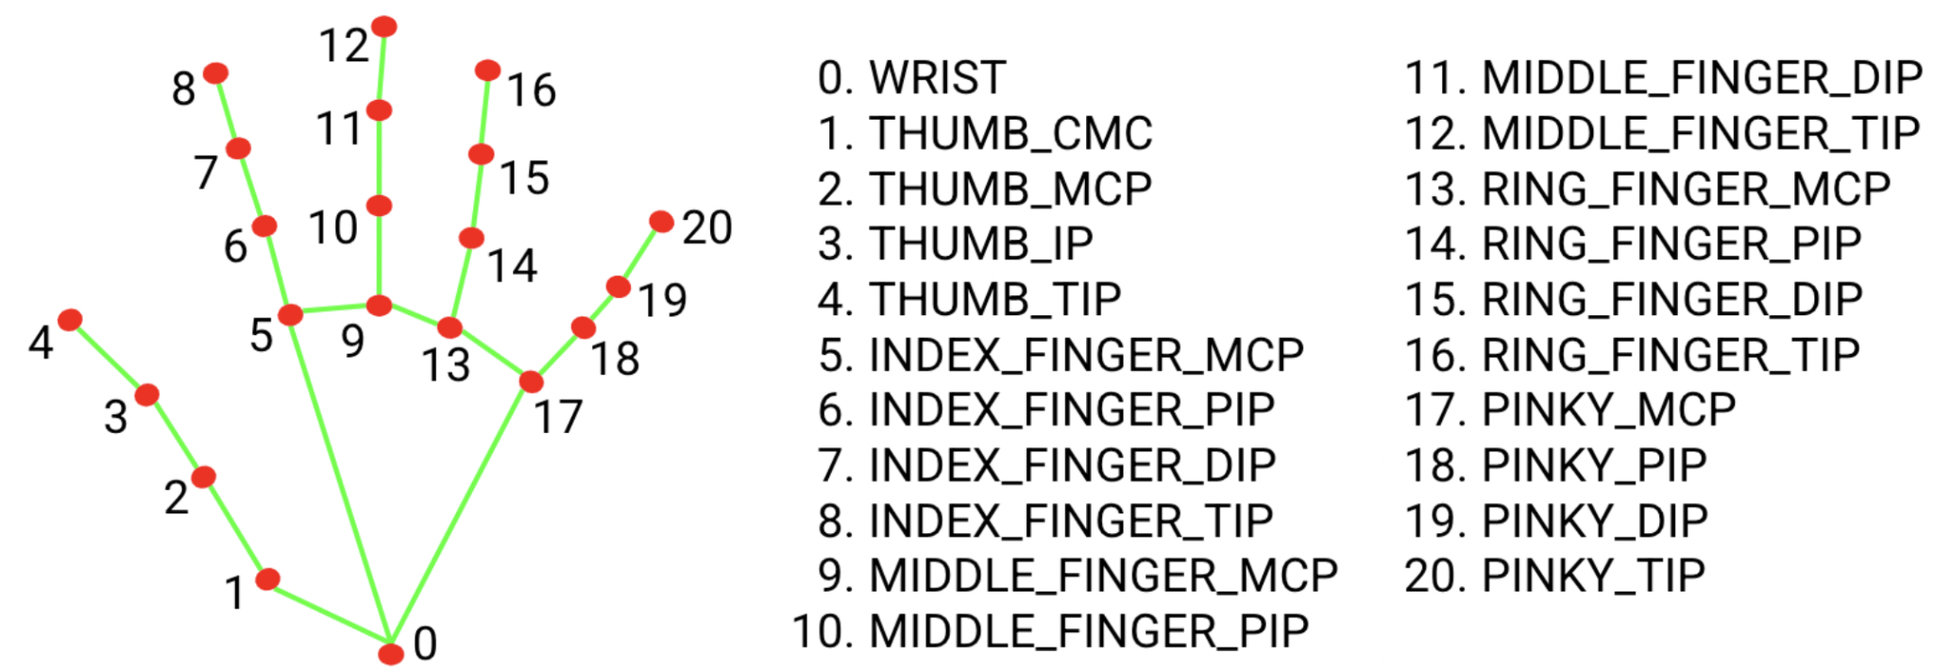

**2. Model Training:**

A Random Forest Classifier model was trained on the extracted features.

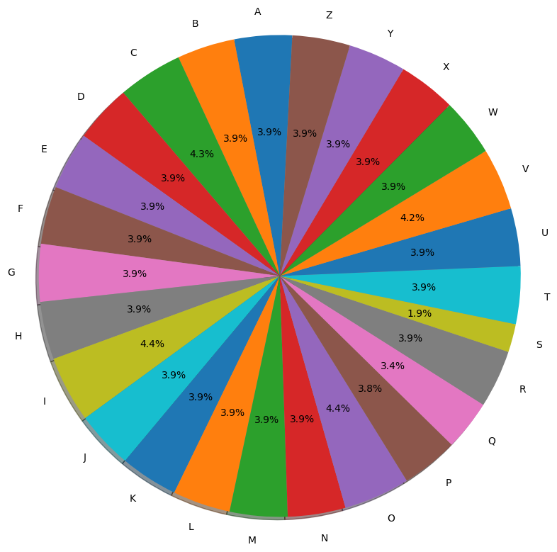

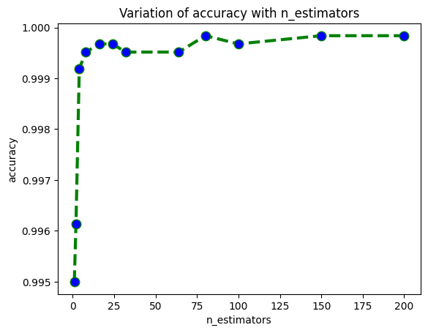

**3. Model Deployment:**

The trained model was deployed to classify the signs made by the user in real-time.

Flowchart of the project: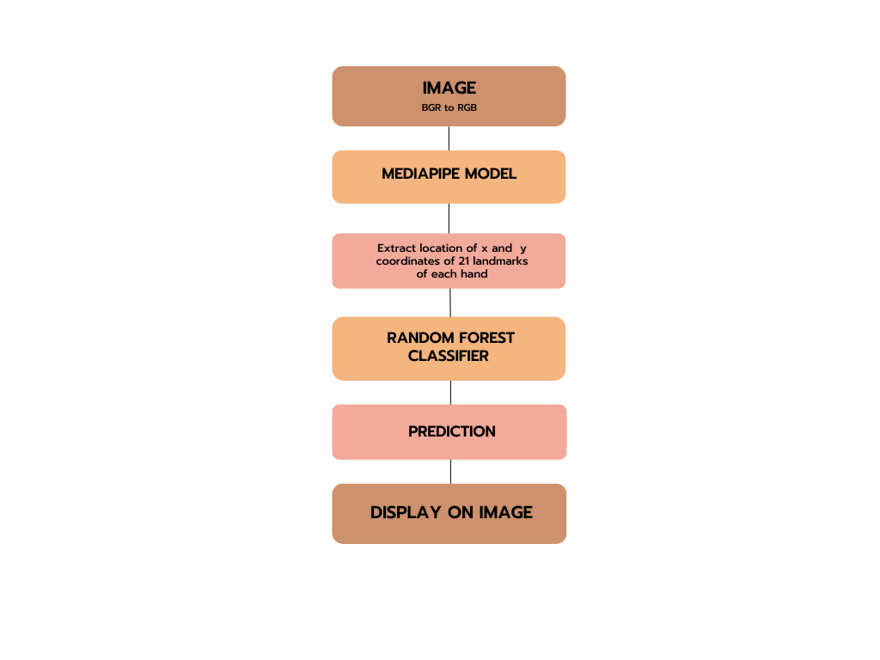

**Results and Future Scope:**

While the current Random Forest Classifier achieved a satisfactory level of accuracy, Deep Learning models such as Convolutional Neural Networks (CNN) can potentially provide even better accuracy for sign language recognition. CNNs are specifically designed for image and video recognition tasks and have been successfully applied to various computer vision tasks, including sign language recognition.

Additionally, we experimented with Google's Teachable Machine, a cloud-based platform that allows users to train machine learning models without writing any code. However, the accuracy achieved by Teachable Machine for ISL sign recognition was much lower than the Random Forest Classifier. This highlights the importance of selecting appropriate machine learning models and datasets for specific tasks.

Moreover, recognizing gestures made by both hands simultaneously can greatly enhance the system's usefulness for real-life scenarios where multiple signs are used together to form sentences. This would require additional data and more complex models, but the benefits of such a system would be immense in facilitating communication between the hearing-impaired and non-hearing-impaired communities.

Furthermore, the project's scope can be extended to develop a sign language translator that can translate recognized signs into text or speech. This could be done using natural language processing techniques and could greatly enhance communication between hearing-impaired individuals and non-sign language users. The potential impact of such a system could be immense in promoting inclusivity and reducing communication barriers for hearing-impaired individuals.

**Limitations of the project:**

The project can only recognize the signs that are present in the ISL dataset, and may not work well in low-light conditions or with poor image quality. Nonetheless, the Sign Language Detection project is a crucial development towards enhancing communication for hearing-impaired individuals. The project has the potential to be extended and applied in various areas, such as sign language translation and human-computer interaction.